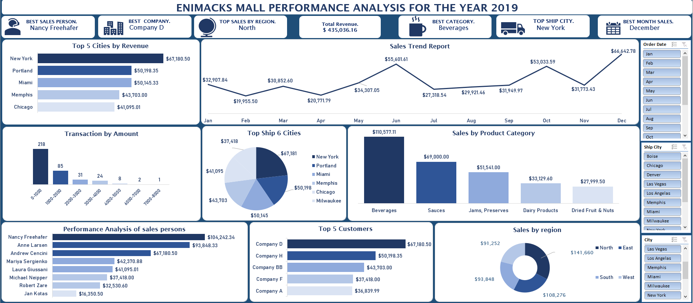

This project aimed to analyze the performance of sales persons, best performing region, best payment methods, best product category and sales trend of Enimacks mall for the year 2019. Examining sales trends will help improve sales and customer satisfaction in the coming year.

**STORY OF DATA**

The Data is telling a story around goods sold by the firm situated in different countries, with different quantities purchased and sales persons including sales made.

**Data Splitting.**

The data is split into two categories

**Category One** - Independent values

Customer Name

Customer ID

Address

City

State

Country

Region

Sales Person

Shipper Name

Ship Name

Ship Address

Payment Type

Product Name

**Category Two** - Dependent values

Order ID

Zip Code

Postal Code

Quantity

Revenue

Unit Price

Shipping Fee

Shipped Date

**OBSERVATIONS**

1. Upon slicing, I observe that Andrew is from New York and the sales person for the Eastern Region and has very poor sales in the month of April, did well in January, June and December and averagely on the other months. I also observe his best sales product for the year is Jams and Preserves where he sold a total of $41391.00 and generated a total sum of $67180.50 in Revenue.

2. I observe Anne has served as a sales person in Memphis and Miami respectively and from the southern region where she made sales of $50145.33 in Miami and $43703 in Memphis. Anne did perform really well in June, Oct, Nov, Dec. Anne was able to generate a total sum of $93848.33 in total revenue in the year 2019.

3. I observed that Jan is from the West Region of Denver and has the least sales for the year with a total sum of $16350.5 in revenue for the year 2019.

4. Laura is from Chicago and a sales person in the East region. Laura only performed averagely in June and December and did poorly in March while the rest of the month are also below average. Laura made a total sale of $41095.01 in total revenue for the year 2019.

5. Mariya is from the West, and her sales report seems to be fluctuating. Her major sales in 2019 are in January, April, May, December where she made sales of $5210.65, $6664.75, $5451.95, $7653.16 respectively. Mariya made a total sale of $42370.88 in revenue for the year 2019.

6. Michael serves as a sales person in the North and from Milwaukee and I also observe that his sales trend has been more of rising and falling while October and December were his major sales with $6738.5 and $5699.95 respectively and making a total sale of $37418.00 in total revenue.

7. I notice Nancy is from the North and the highest sales person for the year 2019. While raking her major sales from goods ranging between 0$ -1000$ with about 45 items of this goods sold in 2019. Nancy has made a total sale of $104242.34 in total revenue in the year 2019 making her the BEST sales person for the year 2019. Nancy has served as a sales person in cities like Portland, Seattle and Boise but made her major sales in Portland with $50,198.35 in total revenue for the year 2019.

8. Robert is from the West and has served as a sales person in Salt Lake City generating a total revenue of $32,530.60 in 2019. I observe a total down sale of $260.55 in total revenue for the month of February in the year 2019.

9. I observe that the Eastern region made more sales of Jam and Preservative products with a total sale of $50,241.00. I also notice the two sales people from the East region are Andrew and Laura. The total sales for the Eastern region in total revenue is $108,275.50 ranking the second highest for the year 2019. I observe that 3 customers have patronized this region and they are Company D, J and Y. The top customer for this region has been company D purchasing a total goods of $67,180.50 in total revenue.

10. I notice that the North has been the best performing region, generating a total sale of $141,660.34 in total revenue. The two sales persons in the North are Nancy and Michael. The customers patronizing the Northern region are Company H, F, A, and G. Company H has been the best company patronizing from the Northern region. Best sales products are Beverages in the North. It is observed that October and December generated the highest sales, raking in $21,424.25 and $21,873.31 in October and December respectively.

11. One major observation from the Southern region is, there's just one sales person in this region. Most goods sold in this region are Beverages, raking a total sum in revenue of $29,278.08 from these goods. Anne is the only sales person in the Southern region. Patronage comes from Company BB, Z, and K while Company BB has been the best customer for the Southern Region. Her best sales for the year 2019 are December where she made a total sale of $12,458.47 in revenue and generated a total of $93,848.33 in the year 2019.

12. Mariya, Robert and Jan are sales persons for the West having a total sale of $91251.98. I observe that companies I, C, CC, L, and AA are the customers purchasing from the West Region. The best category product for this Region is Beverages, Dairy Products, Sauces and Pasta generating revenue of $22,501.13, $18,444.00, $18,080.00, and $11,056.50 respectively.

**RECOMMENDATIONS**

1. I recommend Company AA be contacted to ascertain the reason for the low patronage and also given a discount to encourage them to buy more.

2. Nancy performed best for the year. I recommend her sales strategy should be analyzed and management should also introduce training programs for other sales

persons that can boost sales in the coming year. Commission for the best sales person could also be introduced to motivate other sales persons.

3. I recommend another sales person be added to the South to assist Anne who is the only sales person in that region. This will increase the human capital in the South for effectiveness.

4. Jan performed least for the year and I do recommend he be sent for training on sales and customer retention.

5. Top Companies like D and H should be targeted for loyalty programs or companies D and H for discounts to encourage them to purchase more in the coming year.

6. The sales trend shows a noticeable low sale in February and April. I recommend launching seasonal sales promotions, discount sales or adjusting the price of products to encourage more sales or measures implemented in December for months with low sales.

7. Finetune and implement sales strategies in the North and convene this to other salespeople in other regions especially in the West.

8. Beverages lead the sales with $110,577.11 making it the highest sales product by category. I recommend that beverages should always be made available in stock or increasing stock levels to maximize profit.

**CONCLUSION**

This analysis provides report on customers' purchases, best-selling products, best sales persons and sales trend report.